OpenScape Desk Phone CP Telephone

Family

The OpenScape Desk Phone CP family offers three meticulously conceived, compact and easy-to-administer devices to fulfill the infinitely varied needs of a multitude of users.

OpenScape
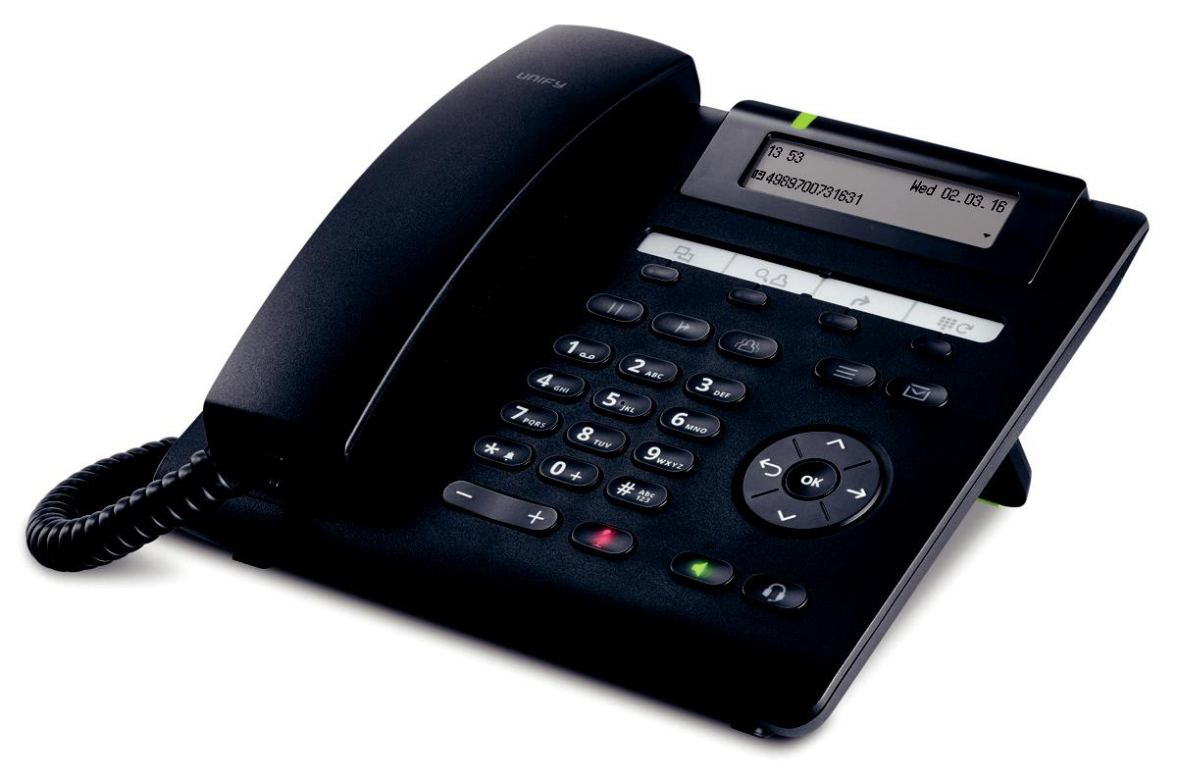
Desk Phone CP200

Intuitive, space-saving and convenient

The ergonomically designed, user-friendly and economical devices of the OpenScape Desk Phone CP telephone family are equipped with a wide vari-ety of functions. They can be easily and conveniently operated, without having to make any compromises in the crys-tal-clear HD audio quality or perfor-mance.

Interoperability

OpenScape
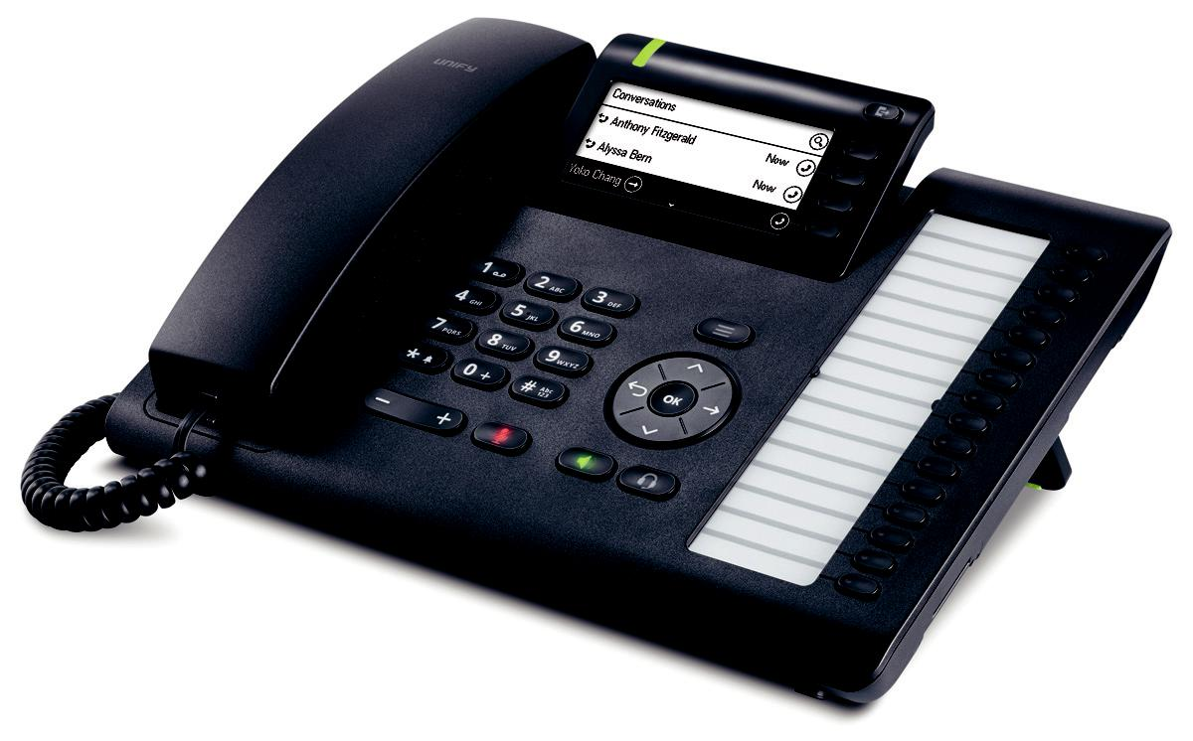
Desk Phone CP400
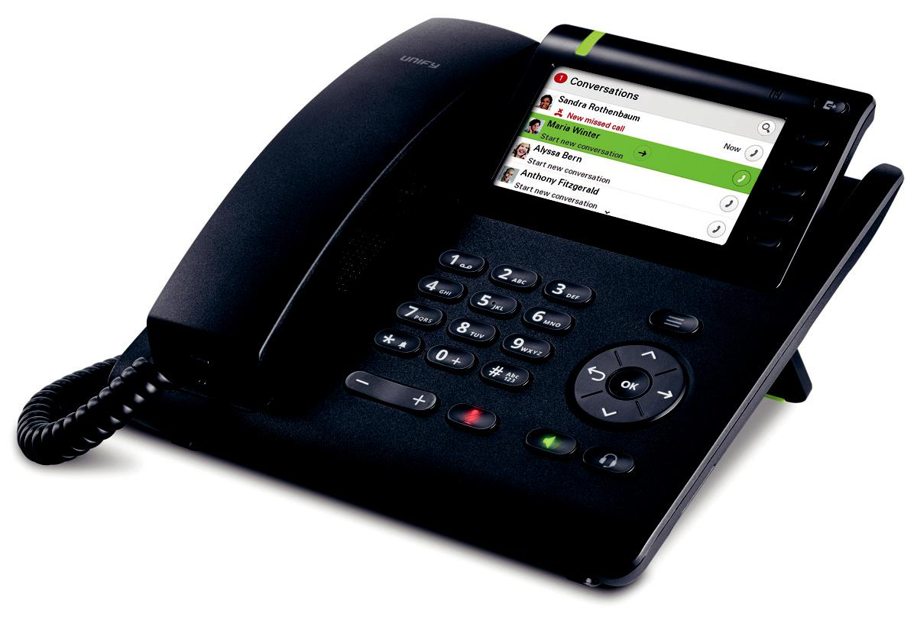
The OpenScape Desk Phone CP family provides for interoperability between the office telephone and other devices via Bluetooth®, incl. Bluetooth LE Bea-con facilitated by Eddystone™.NFC (Near Field Communication) and Cir-cuit make these telephones into a high-performance communications center.

Devices of the OpenScape Desk Phone CP family can be integrated in existing IT/IP infrastructures without any problems. Each telephone features an integrated Ethernet switch and is sup-plied with electrical power by means of Power over Ethernet.

OpenScape

Desk Phone CP600

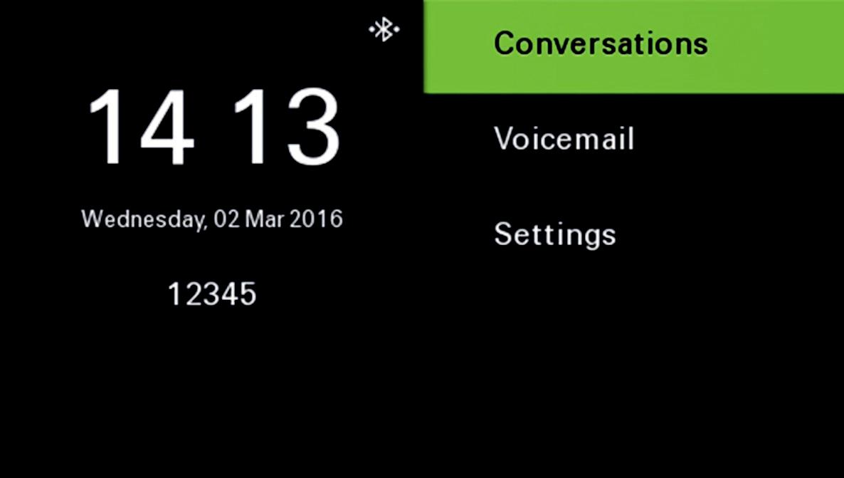

Main menu for the CP600
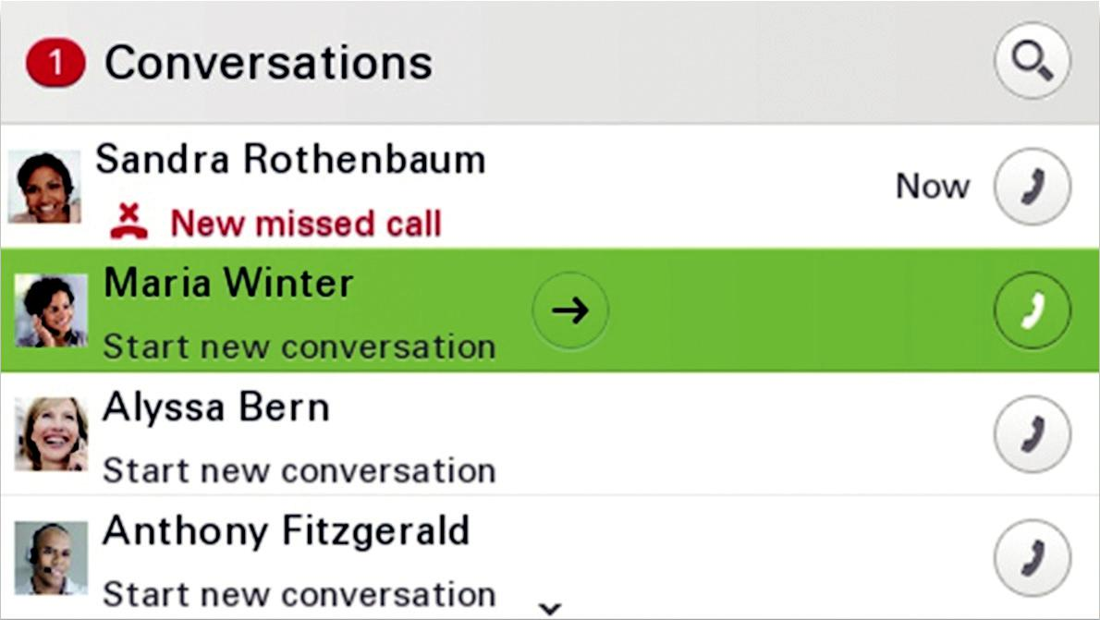

Establish a call
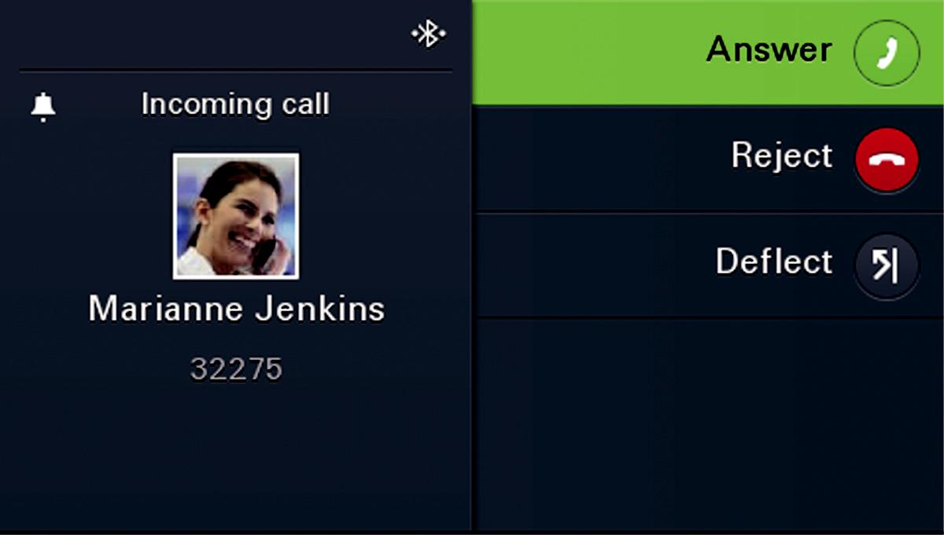

Incoming call
Acoustics

OpenScape Desk Phone CP works with the latest advances in the field of acoustics, and thus offers superb voice quality in the hand-held unit and hands-free mode.

All models are standard-equipped with a high-quality hands-free feature. In addition, each model offers a connec-tion option for professional headsets.

Experience ...

AudioPresenceTM

The OpenScape Desk Phone CP product family offers the industry's leading HD voice transmission –

AudioPresenceTM HD.

AudioPresenceTM HD ensures that the users of these telephones can get an immersive audio experience for voice calls and audio conferenc-es. AudioPresenceTM HD is provided for the entire portfolio of the Open-Scape Desk Phone CP product fam-ily.

AudioPresenceTM HD leverages the standards-based G.722 high-defini-tion audio codec, best-in-class speaker, microphone and acoustic components, as well as advanced noise suppression and echo cancel-lation on all Desk Phone CP models.

New and state-of-the art user interface

The colored graphical user interface of the Desk Phone CP600 provides clear legibility and is therefore also easily and intuitively operable during a phone call. All necessary information and functions can be readily recog-nized.

Circuit integration

Unify is the first company to offer the integration of OpenScape Desk Phone CP400/CP600 devices with the Circuit Collaboration software. This integra-tion provides Unify customers with more comprehensive possibilities for working together within a team. Learn more at www.yourcircuit.com.

Operational software

- SIP software is pre-installed

- Plug & Play / automatic software de-ployment via DLS

- CorNet-IP / HFA (CP200)

Phone models

OpenScape

Desk Phone CP200

Outstanding voice quality, an exten-sive scope of features and a two-line display make this device the ideal choice for users with UC/CTI support.
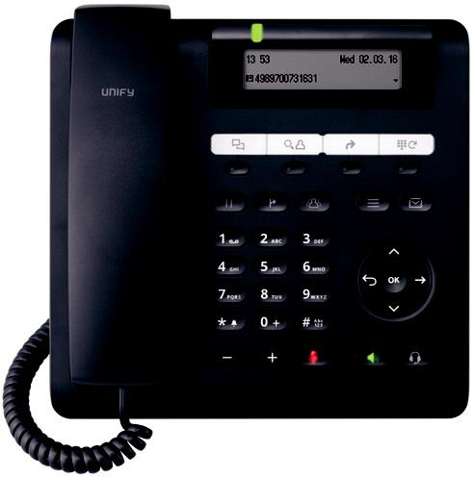

OpenScape

Desk Phone CP400

The larger display and individual op-tions for customization make this tele-phone the ideal solution for office workplaces and teams.
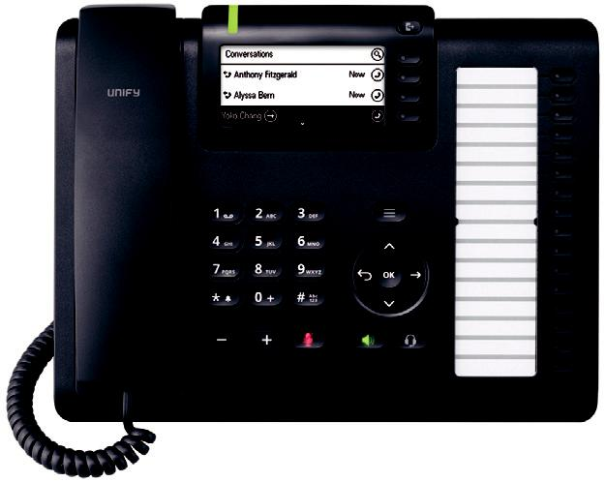

OpenScape

Desk Phone CP600

This device was developed for de-manding users and provides crystal-clear HD voice quality, a brilliant color display and a broad range of functions.
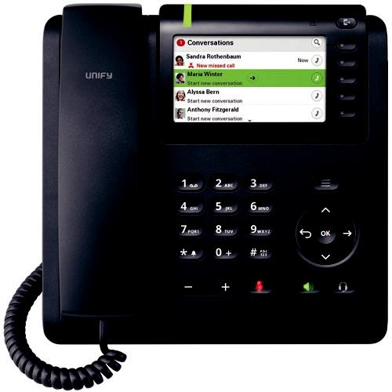

Display

- Graphical two-line display (192 x 48 pixels), monochrome

- Signaling LED (red/green/orange)

Keys

- 4 freely-programmable function keys with an LED (red/green/orange) Pre-assignment: call log, contacts, forwarding, redialing

- 5 fixed function keys, 3 with LED (red or green):
hold, transfer, conference calling, settings, messages

- 4-way navigator plus OK key

- 3 audio function keys (mute/loud-speaker/headset) with LED

- Volume +/-

- Open listening/hands-free speaking (full duplex)

Connection options

• Headset interface (DHSG/EHS)

Placement

- Base, two different placement angles

- Wall-mounting (in the future)

Display

- Pivotable graphical display, 3.7" (240 x 120 pixels), monochrome

- LED backlighting (white)

- Signaling LED (red/green/orange)

Keys

- 4 context-sensitive softkeys with LED (red/green/orange)

- 2 fixed function keys (menu/ab-sence)

- 16 freely-programmable function keys with LED (red/green/orange)

- 4-way navigator plus OK key

- 3 audio function keys (mute/loud-speaker/headset) with LED

- Volume +/-

- Open listening/hands-free speaking (full duplex)

Connection options

• Headset interface (DHSG/EHS)

Placement

• Base, two different placement angles

Display

- Pivotable graphic color display, 4.3" (480 x 272 pixels)

- LED backlighting (white)

- Signaling LED (red/green/orange)

Keys

- 5 context-sensitive softkeys with LED (red/green/orange)

- 2 fixed function keys (menu/ab-sence)

- 4-way navigator plus OK key

- 3 audio function keys (mute/loud-speaker/headset) with LED

- Volume +/-

- Open listening/hands-free speaking (full duplex)

Connection options

- Headset interface (DHSG/EHS)

- Bluetooth 2.1 BR/EDR

- Bluetooth 4.1 LE

- NFC

- Slot for SD card

Placement

- Base, two different placement angles

- Wall-mounting (in the future)

Accessories

Key module KM400

The key module KM400 can also be connected to the Desk Phone CP400.

The 16 freely-programmable keys with LED signaling can have various func-tions assigned as desired.
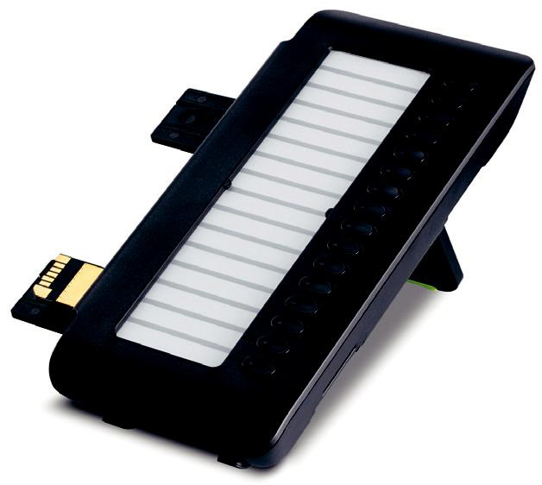

- 16 freely-programmable keys with LEDs (red/green/orange)

- Key labeling using paper inlays

- Max. 2 key modules connectible to a CP400

- Only usable on CP400

Key module KM600

The key module KM600 can also be connected to the Desk Phone CP600.

Each of the 12 freely-programmable keys with LED signaling can be as-signed with functions on two levels. This supplementally increases the pos-sible scope of functions.

The high-contrast, monochrome TFT display enables comfortable and per-fectly legible labeling of each key.
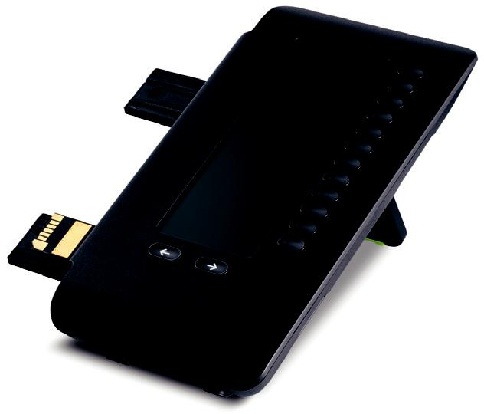

- 12 freely-programmable keys with LEDs (red/green/orange)

- Key labeling by means of a mono-chrome TFT display

- 2 navigation keys for switching be-tween the first and second levels

- Max. 4 key modules connectible to a CP600

- Only usable on CP600

Communications platforms

The OpenScape Desk Phone CP prod-uct family supports SIP (Session Initia-tion Protocol) signaling. The CP200 also supports CorNet-IP / HFA.

The following communications plat-forms are supported:

SIP

- OpenScape Voice V7 R1

- OpenScape Voice V8

- OpenScape Voice V9

- OpenScape 4000 V8

HFA

• OpenScape Business V2 R2

Technical data

 | Desk Phone CP200 | Desk Phone CP400 |  | Desk Phone CP600
Housing color |  | black
Placement angle |  | 2-stage
Handset and base embossed with Unify |  | Yes
logo
Display
Dimensions | Graphical two-line | Graphical display, 3.7" |  | Graphical color display,
 | display |  |  | 4.3"
 | 192 x 48 pixels | 240 x 120 pixels |  | 480 x 272 pixels
Color | Monochrome | Monochrome |  | 16-bit color depth
Backlighting | No | White LED |  | White LED
Adjustable display | No | Yes |  | Yes
Additional optical call alert |  | Yes (red/green/orange)
Keys/LEDs
Context-sensitive softkeys | No | 4 with LED (red/green/ |  | 5 with LED (red/green/
 |  | orange) |  | orange)
Fixed function keys | 5 | 2 |  | 2
 | 3 with LED | (Menu/absence) |  | (Menu/absence)
 | Hold, transfer, confer-
 | ence calling, settings,
 | messages
Free-programmable keys | 4 with LED | 16 with LED |  | None
 | (red/green/orange) | (red/green/orange) |  | Alternative: 4 favorites
 | Pre-assignment: call log, |  |  | with LED (red/green/
 | contacts, forwarding, re- |  |  | orange)
 | dialing
Key labeling | Paper | Paper |  | Display
Audio keys |  | 3
 | (Mute/loudspeaker/headset) with LED
 |  | Volume +/-
Navigation | 4-way navigator, plus OK key
Audio
G.711 (64 kbit/s a/µ-law) |  | Yes
G.722 (64 kbit/s) |  | Yes
G.729AB (8 kbit/s) |  | Yes
Open listening |  | Yes
Full duplex handsfree |  | Yes
Echo canceling for local echo (AEC) |  | Yes
full duplex
Interfaces
LAN connection | 10/100 Mbit/s | 10/100/1000 Mbit/s |  | 10/100/1000 Mbit/s
(Ethernet with auto-sensing)
Integrated switch |  | Yes
Energy Efficient Ethernet (IEEE 802.3az) | No | Yes |  | Yes
Headset jack for cord-connected |  | Yes
(121 TR9-5) and cordless headsets
(121 TR9-5*)
Bluetooth V2.1 BR/EDR | No | No |  | Yes
(hands-free profile, headset profile)

 |  | Desk Phone CP200 |  | Desk Phone CP400 | Desk Phone CP600
Bluetooth Low Energy 4.1 |  | No |  | No | Yes
Passive RFID tag |  |  |  | Yes
Passive NFC tag with: |  | No |  | No | Yes
• | BT MAC address
• | LAN MAC address
SD card slot |  | No |  | No | Yes
VoIP protocol
SIP |  |  |  | Yes
CorNet IP / HFA |  | Yes |  | No | No
Expansions
Connection option for Key module |  | No |  | Yes | Yes
 |  |  |  | Up to 2 KM400 | Up to 4 KM600
Wall mounting kit |  | Yes |  | No | Yes
Security features
Layer 2 authentication (IEEE 802.1x) |  |  |  | Yes
Payload encryption via SRTP |  |  |  | Yes
Signaling via TLS encryption |  |  |  | Yes
Support of digital certificates (X.509 V3) |  |  |  | Yes
HTTPS |  |  |  | Yes
Network
LLDP-MED |  |  |  | Yes
QoS (DiffServ and IEEE 802.1Q) |  |  |  | Yes
IEEE 802.1Q |  |  |  | Yes
Power supply
Power over Ethernet (PoE, IEEE 802.af) |  |  |  | Yes
PoE class |  | 1 |  | 2 | 2
OpenStage power supply (country-spe- |  | Optional |  | Optional | Optional
cific models available) |  |  |  |  | (always necessary as of
 |  |  |  |  | the 2nd Key module)
Certifications
Europe |  | CE mark
USA/Canada |  | NRTL marking
Safety standards |  | IEC60950-1, EN60950-1
 |  | UL60950-1, CAN/CSA-C22.2 No.60950-1
EMC standards |  | CISPR22 Class B, CISPR 24
 |  | EN55022 Class B, EN55024
 |  | FCC Part 15 (CFR 47) Class B
Hearing aid compatibility (HAC) |  | FCC Part 68 (CFR 47) / CS-03 Part V
Technical data
Dimensions (angle (°) x height [mm] x |  | 20° x 113 x 219 x 207 |  | 20° x 143 x 283 x 207 | 20° x 150 x 219 x 207
width [mm] x depth [mm]) |  | 45° x 173 x 219 x 165 |  | 45° x 189 x 283 x 165 | 45° x 193 x 219 x 165
Weight [kg] |  | 0.837 |  | 1.121 | 0.96
Storage conditions |  | -40 °C to +70 °C (-40 °F to +158 °F)
Operating conditions |  | +5 °C to +40 °C (+41 °F to +104 °F)

Notes

Copyright © Unify Software and Solutions GmbH & Co. KG, 12/2016 Mies-van-der-Rohe-Str. 6, 80807 Munich/Germany

All rights reserved.

Reference No.: A31002-C1000-D101-3-7629

The information provided in this document contains merely general descriptions or characteristics of performance which in case of actual use do not always apply as described or which may change as a result of further development of the products. An obligation to provide the respective characteristics shall only exist if expressly agreed in the terms of contract.

Availability and technical specifications are subject to change without notice.

Unify, OpenScape, OpenStage and HiPath are registered trademarks of Unify Software and Solutions GmbH & Co. KG. All other company, brand, product and service names are trademarks or registered trademarks of their respective holders.

unify.com

